WEEK 2 TASK REPORT

Exploratory Data Analysis and Data Preparation

1. Introduction
The purpose of this task is to perform Exploratory Data Analysis (EDA) and Data Preparation using the Titanic dataset. EDA helps in understanding the structure and characteristics of the dataset, identifying missing values and duplicate records, examining distributions, detecting potential outliers, and discovering relationships between variables.
The Titanic dataset contains information about passengers, including their age, gender, passenger class, fare, family details, port of embarkation, and survival status. Python libraries such as Pandas, NumPy, Matplotlib, and Seaborn were used for data analysis and visualization.

2. Dataset Overview
The Titanic dataset contains passenger-level information with variables such as:
- PassengerId
- Survived
- Pclass
- Name
- Sex
- Age
- SibSp
- Parch
- Ticket
- Fare
- Cabin
- Embarked
The Survived variable represents the survival outcome, where 0 indicates that the passenger did not survive and 1 indicates that the passenger survived.

3. Data Cleaning and Preparation
The following data preparation steps were performed:
3.1 Checking Dataset Structure
The dataset was examined using Python to understand the number of rows and columns, variable names, and data types.
3.2 Missing Values
Missing values were identified in variables such as Age, Cabin, and Embarked. Appropriate preprocessing techniques were considered to handle these missing observations.
3.3 Duplicate Records
The dataset was checked for duplicate records to ensure that repeated observations did not affect the analysis.
3.4 Data Types
The data types of different variables were examined and converted where necessary to make them suitable for analysis.
3.5 Outlier Detection
Boxplots were used to identify potential outliers in numerical variables such as Age and Fare.

4. Exploratory Data Analysis
4.1 Univariate Analysis
Histograms and other plots were used to understand the distribution of numerical variables such as Age and Fare.
4.2 Categorical Analysis
Categorical variables such as Sex and Pclass were examined to understand the distribution of passengers across different groups.
4.3 Relationship with Survival
The relationship between passenger characteristics and survival was explored. Variables such as Sex and Passenger Class showed noticeable differences in survival outcomes.
4.4 Visualization
Different visualizations were created using Matplotlib and Seaborn, including:
- Count plots
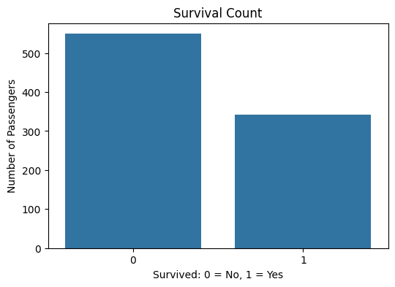
- Boxplots
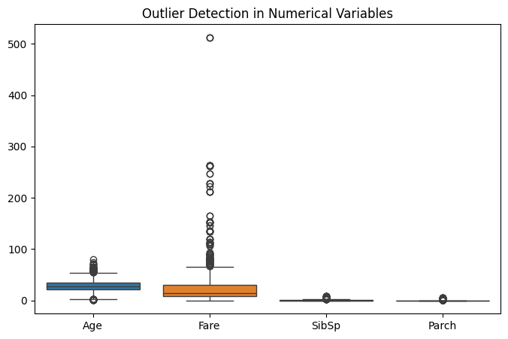
- Survival-based categorical plots
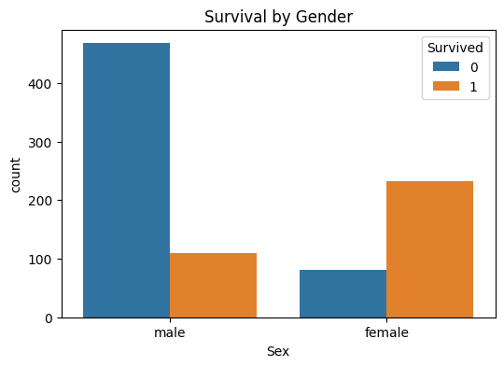
- Survival-based pessenger plots
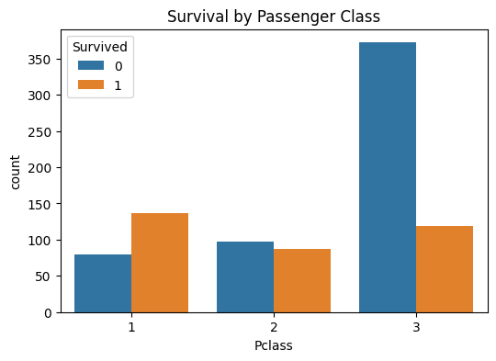

5. Initial Insights
The Exploratory Data Analysis (EDA) of the Titanic dataset provided several initial insights into the characteristics of the passengers and their survival outcomes. The dataset contains demographic and travel-related variables such as Age, Sex, Passenger Class (Pclass), Fare, SibSp, Parch, and Embarked.
During the initial analysis, missing values and duplicate records were examined as part of the data quality assessment. The analysis indicates that Sex, Passenger Class, Age, and Fare may have an important relationship with passenger survival.
Female passengers show a comparatively higher survival rate than male passengers. Similarly, passengers belonging to higher passenger classes generally show higher survival rates compared with passengers from lower classes. The Age variable contains missing observations, making appropriate treatment of missing values necessary before further analysis.
The Fare variable shows considerable variation among passengers. Histograms and boxplots help in understanding the distribution of numerical variables and identifying potential outliers. These initial observations provide a foundation for further statistical analysis and predictive modelling.

6. Rationale
The main purpose of performing EDA and data preparation is to understand the quality, structure, distribution, relationships, and potential problems within the dataset before applying statistical or machine learning techniques.
Missing-value treatment is important because incomplete observations can affect the accuracy and reliability of subsequent analysis. Duplicate records were also checked to ensure that repeated observations do not influence the results.
Histograms were used to understand the distribution of numerical variables, while scatter plots were used to examine possible relationships between numerical variables. Boxplots can help identify extreme values and potential outliers.
Categorical variables need to be appropriately encoded before they can be used in machine learning models. Numerical variables may also require transformation or normalization depending on their distributions and the requirements of the selected modelling technique.
Therefore, EDA and data preparation provide an important foundation for obtaining meaningful insights and preparing the Titanic dataset for further statistical analysis, visualization, and machine learning.

7. Conclusion
In this Week 2 task, Exploratory Data Analysis and Data Preparation were performed on the Titanic dataset using Python. The dataset structure, data types, missing values, and duplicate records were examined as part of the initial data-quality assessment.
Various data-cleaning and preprocessing techniques were applied to make the dataset more suitable for further analysis. Visualizations such as histograms, scatter plots, and boxplots were used to understand variable distributions, identify potential outliers, and examine relationships between variables.
The analysis provided preliminary observations indicating that variables such as Sex, Passenger Class, Age, and Fare may be relevant when studying passenger survival. These observations can be investigated further through statistical analysis and machine learning techniques.
Overall, the EDA and preprocessing steps helped transform the raw Titanic dataset into a more organized and analysis-ready form. The prepared dataset can be used in subsequent stages for advanced visualization, statistical analysis, predictive modelling, and evaluation of passenger survival patterns.

8. Tools and Technologies Used
Tool/Library | Purpose
Python | Data analysis and programming
Pandas | Data manipulation and cleaning
NumPy | Numerical operations
Matplotlib | Data visualization
Seaborn | Statistical visualization
Google Colab/Jupyter Notebook | Development environment

9. Future Scope
The prepared Titanic dataset can be used for further analysis and predictive modelling. Future work may include:
- Feature engineering.
- Encoding categorical variables.
- Feature scaling and normalization.
- Building machine learning models.
- Comparing different classification algorithms.
- Evaluating model performance using suitable metrics.
- Predicting passenger survival based on important features.

